Module 1- Designing Static Pages using HTML

**Thought Note**

**Website for Pune Tourism**

**Name: -** Snehalata Yewale **Email: -** jagdalesnehalata7@gmail.com

**Name of Company: -** Yewale Tours & Travels (**Name for Assignment Only**)

**Name of Website: -** Pune Tourism

**Module 1-Assignment 1-** Designing Static Pages using HTML

**Thought Note**

I am creating website for your “**Yewale Tour and Travels**” company for **“Pune Tourism”.**

I made Home Page, About Us, Contact Us Page and Climate page.

**1] Home Page:**

It is main page which contain About Us, Contact Us Page and Climate page direct link which opens in separate new window. In home page also use <iframe> tag with about us page link.

**Reference Links**-

* Pune Historic places Images is downloaded from **Google** and some from <https://unsplash.com>
* Logo is created by using [https://www.canva.com](https://www.canva.com/p/templates/EAFYQucKECk-vintage-and-retro-holiday-travel-agent-logo/) website.

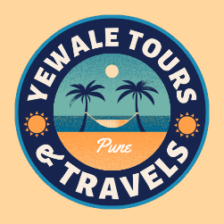

**2] About Us page**:

It contains Pune City History.

**3] Contact Us Page:**

It contains from in which user can fill the personal details like Name, Email, City, Phone Number

Message field. By using <form> tag with <label> and <input> attributes.

**4] Climate Page:**

This page Is all about Pune City Climate by Month.

**Reference Link -** <https://en.climate-data.org/asia/india/maharashtra/pune-31/>

Pune Climate Reference from above website.